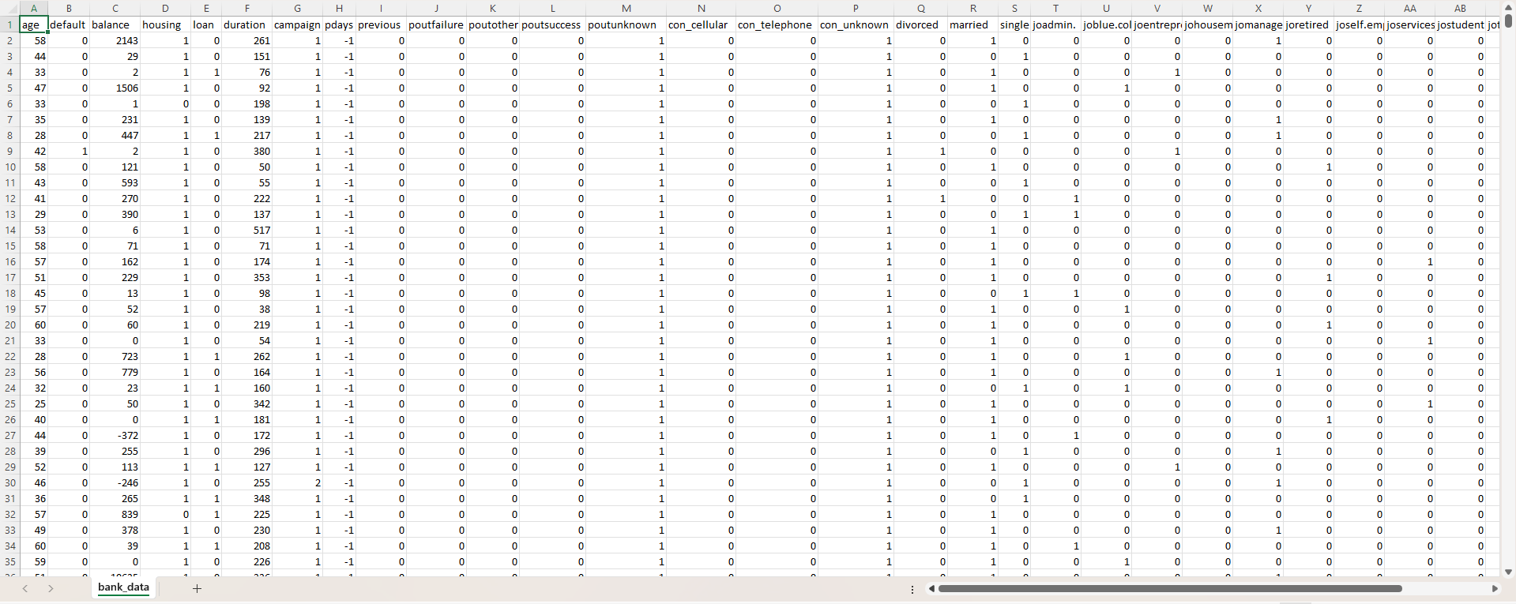

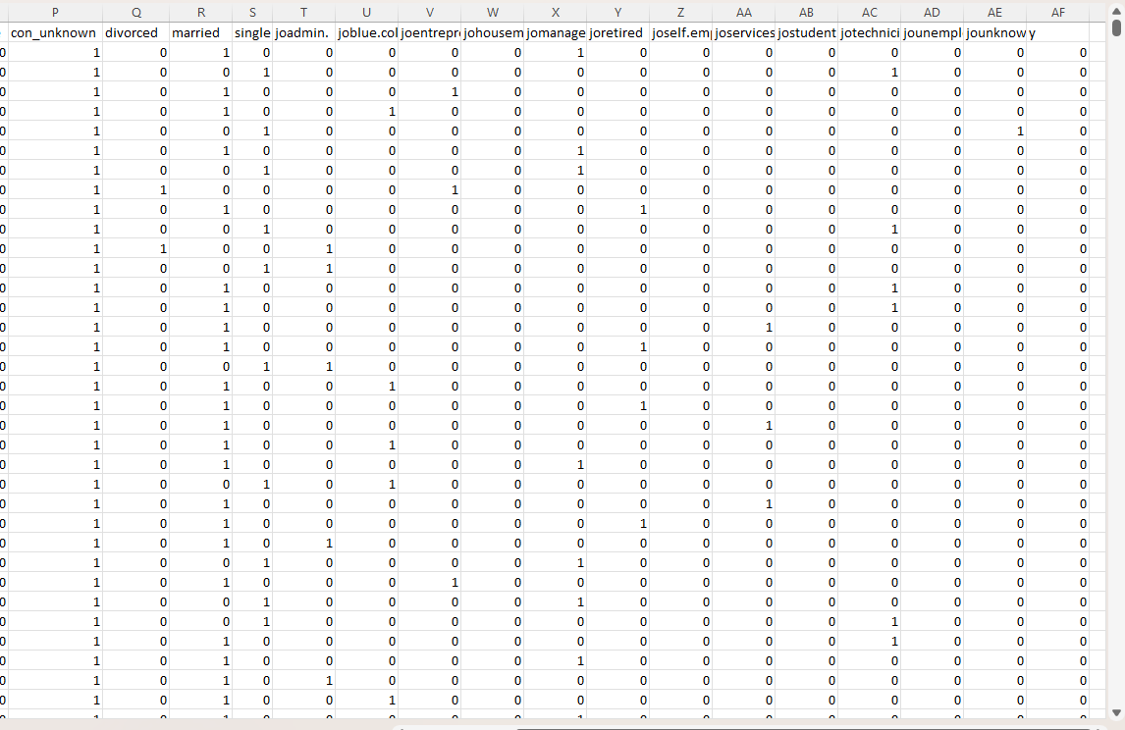

Name of Feature Description Type Relevance w.r.t other Features
1.Age Age of the User Quantitative, Continuous Relevant, correlates with Gender and
banking facilities
2.Default Constant value Quantitative, Binary Irrelevant, feature has no variation
other than binary value
3.Balance Account Balance Quantitative, continuous Relevant, correlates with remaining
Amount balance in
employed/unemployed
Persons account
4.Housing_loan Home Loan account Quantitative, Continuous Relevant, correlates with
employed user with minimum
account balance criteria
5.Duration Time period Quantitative, Discrete Relevant, correlates with time period
criteria given to customer to fulfill
loan in the form of days, months or weeks
6.Campaign Number of Contacts performed Quantitative, Discrete Relevant, it relates with client
which is contacted number of times for
loan interests and other facilities
7.pdays client contacted P days ago Quantitative, Discrete Relevant, it relates with client
contacted last time since P days
8.Previous No. of times client contacted Quantitative, Discrete Relevant, it relates with the count, no of
times bank contacted this user before
this campaign
9.pout_failure Failure output Quantitative, Binary Partially Relevant, it is the failure
outcome of previous campaign
10.pout_other ‘Other’ field Qualitative, Nominal Marginally Relevant, it is the ‘Other-
Field not mentioned in the ideal list
11.pout_success Successful output Quantitative, Binary Partially Relevant; it is the outcome of
the previous campaign
12.pout_unknown Unknown Outcome Qualitative, Binary Partially Relevant; it is the missing
output of the previous campaign
13.con_cellular Mode of Contact Qualitative, Binary Partially Relevant; if the mode of contact is Mobile phone, then it is 1, else 0
14.con_telephone Communication Type Qualitative, Binary Partially Relevant; if the mode of contact is landline phone, then it is 1, else 0
15.con_unknown Missing contact Qualitative, Binary Partially Relevant; if the contact is missing, then it is 1, else 0
16.divorced Marital status Qualitative, Binary Partially Relevant; if the user is divorced, then it is 1, else 0
17.married Marital status Qualitative, Binary Partially Relevant; if the user is married, then it is 1, else 0
18.single Marital status Qualitative, Binary Partially Relevant; if the user is single, then it is 1, else 0
19.jo_admin Administrative Role Qualitative, Ordinal Relevant, Admin gathers forms and routes users to appropriate banking departments
20.jo_blue_coll Blue Collar worker Qualitative, Nominal Irrelevant, these workers can have
the loan requirement in bank
21.jo_enterprenue Self-Employed Qualitative, Nominal partially Relevant, Entrepreneurs
visit banks for deposits, loans, or cards, maintaining locker accounts
22.jo_housemaid Homemaker Qualitative, Nominal Low Relevance, Homemaker visits
bank to open a saving account to deposit her salary
23.jo_manager Manager Role Qualitative, Ordinal Highly Relevant, Bank manager decides on lockers, loans, and other activities.
24.jo_retired Retired Person Qualitative, Nominal Relevant, Retired person visits bank for other senior citizens pension plans and benefits
25.jo_self_employed Businessman/woman Qualitative, Nominal partially Relevant, Entrepreneurs
visit banks for deposits, loans, or cards, maintaining locker accounts
26.jo_services Service sector worker Qualitative, Nominal Relevant, Bank employers has loan, locker account, holidays, pension
Benefits
27.jo_student Student Role Qualitative, Nominal Low Relevance, students can have benefits about education loan
28.jo_technician Technician Role Qualitative, Nominal Low Relevance, A Technician can
open and save in a savings account

